1. “ : “ is nguoc lai
2. “ ! “ daor
3. Label: lbValue

* Anchor: drag the corner of the form

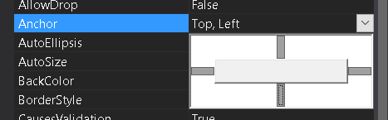

1. Font:

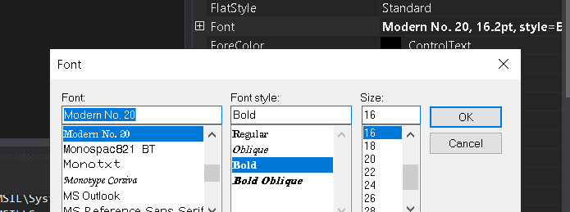

* + When press the form then change text in the label
    1. private void Form1_Click(object sender, EventArgs e)
    2. {
    3. label1.Text = "free education...";

}

* + Show a new form:

// show form 2

Form2 t = new Form2();

t.Show();

or t.ShowDialog();

* Use the label in form 2 in form 1:

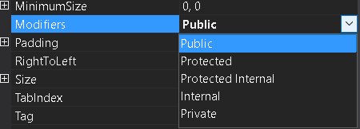

1. Button btnValue
   * 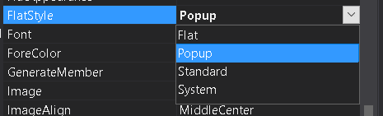
   * 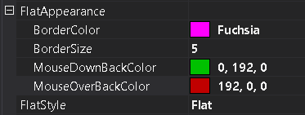
   *  when press Enter button it will execute the btnValue button.
   *  when pess Esc button
2. Text box: txbValue
   * 
   * 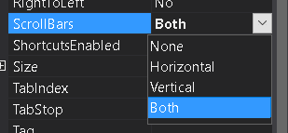
   * 
   * 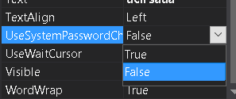
   * 
   * 
   * Event: text change is more used
   * 
3. Checkbox ckbName
   * 
   * 
4. Panel and Flow layout panel:

* 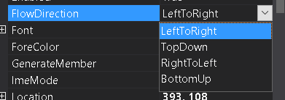
* 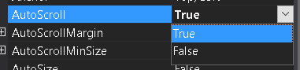

1. ComboBox
   * 
   * 
   * 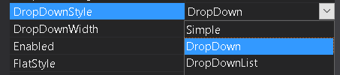
   * 
   *  Event
2. Image:pcb
   * 
   * 
   * 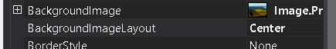
3. List view:
   * 
   * 